**Operating System**

**Lab Report**

**Lab 01**



|  |  |
| --- | --- |
| Group Members Name & Reg #: | **Muhammad Haris Irfan**  **(FA18-BCE-090)** |
|  |  |
| Class | Operating System (**BCE-5B**) |
| Instructor’s Name | Sir Wasif |

**In Lab Tasks**

**Question 1: Task 1:**

**In this activity, you are required to perform tasks given below:**

**1. Display the current date**

**2. Display the calendar for the current year**

**3. Display the calendar of 2012**

**4. Display the calendar of Feb 2015**

**Solution:  
1)** The Terminal Output is given below,

**2)** The Terminal Output is given below,

**3)** The Terminal Output is given below,

**4)** The Terminal Output is given below,

____________________________

**Question 2: Activity 2:**

**Perform the following tasks using Linux CLI commands**

**1. Display the amount of free storage on your machine**

**2. Display the amount of free memory on your machine**

**3. Display the username of the current user**

**4. Open the man of date free command**

Solution:

1) The Terminal Output is given below,

The result for this program is shown below,

_____________________________

2) The Terminal Output is given below,

3) The Terminal Output is given below,

4) The Terminal Output is given below,

_____________________________

POST LAB (Home Activities)

6.1 Question 1:

In GUI open the Libre Office writer tool create a document that contains information about your favorite place. Try the following short- keys while formatting the document

Solution:

_______________

6.2 Question 2:

**Write a function to sort data (in increasing order) in an array.**

Solution:

I am attaching my code below,

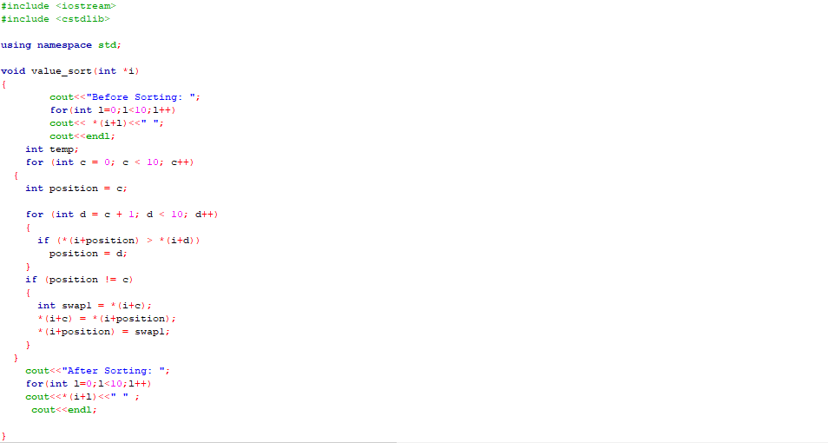

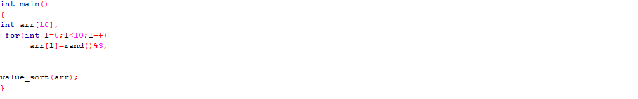

The result for this program is shown below,

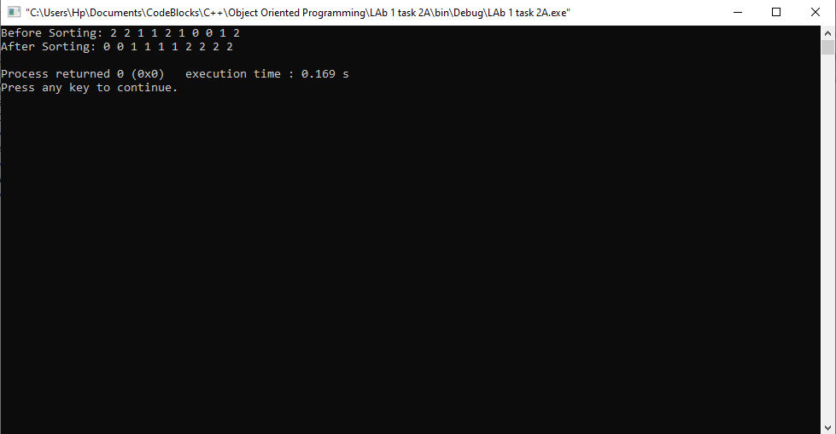

The above sorting is done by passing reference, because you cannot pass an array by value.

_______________

6.3 Question 3:

**Write a program that inputs a string value from the user and displays it in reverse using pointer.**

Solution:

I am attaching my code below,

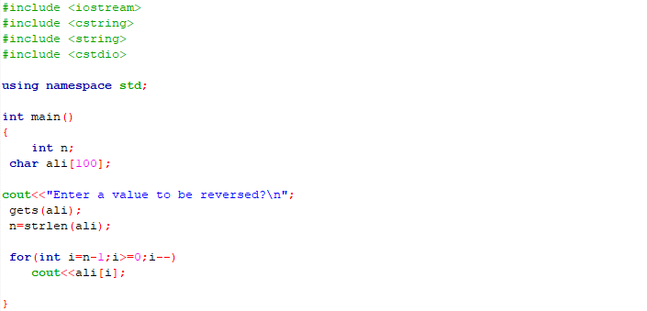

The result for this program is shown below,

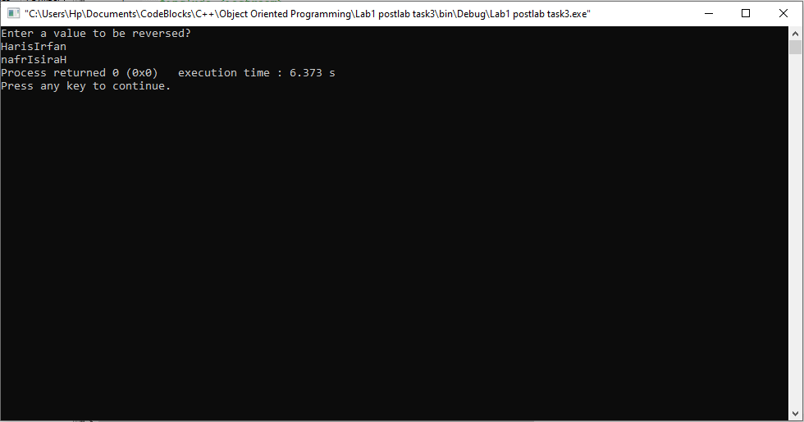

______THE END________

_______________